Child New Patient Questionnaire

Name______________________________________ Gender_______________________________
Age_____ DOB____________ Time of birth________ Place of birth___________________________
Form completion date___________________ Person completing form________________________
Names and phone nos. of parents_____________________________________________________
Names and age of siblings___________________________________________________________
- Significant prior medical issues and surgeries:
________________________________________________________________________________
________________________________________________________________________________
________________________________________________________________________________
________________________________________________________________________________
2. Significant medical issues in your family:
________________________________________________________________________________
________________________________________________________________________________
________________________________________________________________________________
________________________________________________________________________________
________________________________________________________________________________
- Allergies (include reaction)________________________________________________________
________________________________________________________________________________
- Please describe the pregnancy and birth:
________________________________________________________________________________
________________________________________________________________________________
________________________________________________________________________________
________________________________________________________________________________
________________________________________________________________________________
________________________________________________________________________________
- Describe development:
Crawling______________________________________________________________________
Walking_______________________________________________________________________
Talking_______________________________________________________________________
Overall Motor__________________________________________________________________
Saying “I”_____________________________________________________________________
Other comments _______________________________________________________________
- What do you feel your child needs help with? (Please list most important first)
________________________________________________________________________________
________________________________________________________________________________
________________________________________________________________________________
- Does the child follow regular daily rhythms? Please describe:
________________________________________________________________________________
________________________________________________________________________________
________________________________________________________________________________
- What medications, supplements and/or remedies does your child take? Please include doses. Any other treatments?
________________________________________________________________________________
________________________________________________________________________________
________________________________________________________________________________
________________________________________________________________________________
________________________________________________________________________________
- Biography: Please describe significant emotional/physical/spiritual events so far in your child’s life and/or your family life?
________________________________________________________________________________
________________________________________________________________________________
________________________________________________________________________________
________________________________________________________________________________
________________________________________________________________________________
- Does your family follow a spiritual/religious path?
________________________________________________________________________________
________________________________________________________________________________
- Describe each of the following:
Sleep patterns:
________________________________________________________________________________
________________________________________________________________________________
________________________________________________________________________________
Digestion (appetite, bowel movements - diarrhea/loose/regular/constipation, gas):
________________________________________________________________________________
________________________________________________________________________________
________________________________________________________________________________
Breathing:
________________________________________________________________________________
________________________________________________________________________________
Urination:
________________________________________________________________________________
________________________________________________________________________________
Menses (if applicable):
________________________________________________________________________________
________________________________________________________________________________
Skin (rashes, moisture, reactivity to topical treatments):
________________________________________________________________________________
________________________________________________________________________________
Bodily warmth/coolness: ________________________________________________________________________________
________________________________________________________________________________
Emotional life (feelings/moods/soul life):
________________________________________________________________________________
________________________________________________________________________________
________________________________________________________________________________
Thinking/Memory (Describe your child’s thinking. Is the child better with details or the overall picture?)
________________________________________________________________________________
________________________________________________________________________________
________________________________________________________________________________
Food cravings/aversions:
________________________________________________________________________________
________________________________________________________________________________
Eating rhythms (Are they regular etc. ?):
________________________________________________________________________________
________________________________________________________________________________
Movement: Describe your child’s movement. Can your child be still?
________________________________________________________________________________
________________________________________________________________________________
________________________________________________________________________________
Social life: How does your child relate to peers and the environment?
________________________________________________________________________________
________________________________________________________________________________
________________________________________________________________________________
________________________________________________________________________________
Behavior: Do you have concerns regarding your child’s behavior? If so, please describe:
________________________________________________________________________________
________________________________________________________________________________
________________________________________________________________________________
________________________________________________________________________________
________________________________________________________________________________
________________________________________________________________________________
________________________________________________________________________________
Transitions:
_____________________________________________________________________________
_____________________________________________________________________________
How does your child react to stress?
_____________________________________________________________________________
_____________________________________________________________________________
Temperament: Please choose the #1 and #2 reaction that most often fits your child:

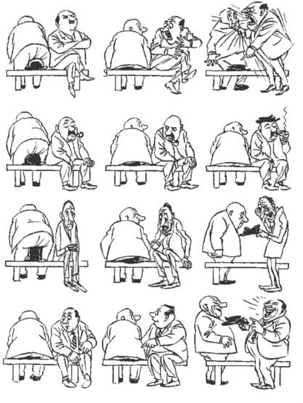
- If old enough, please ask your child to draw a picture of him/herself, your family and the home you live in. Please make all colors of crayons available and bring the drawing to the next office visit.

